Doc No: BCIM/HYD/MS/ LH10/04
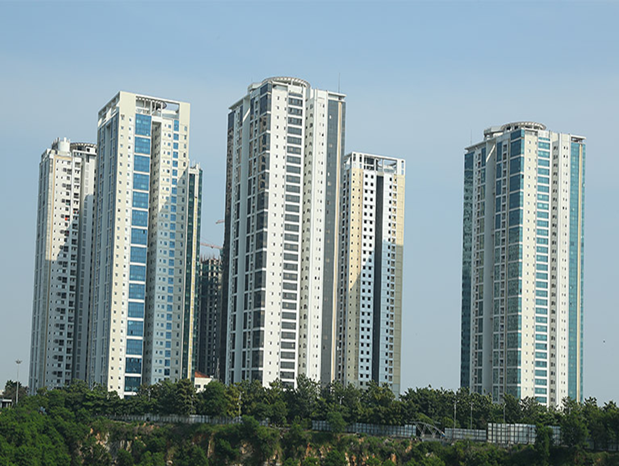
Project Name |  | LANCO HILLS RESIDENTIAL PROJECT- LH 10 ,HYDERABAD
Client |  | LANCO HILLS TECHNOLOGY PARK PRIVATE LIMITED
PMC |  | SAVILLS PROPERTY SERVICES (INDIA) PRIVATE LIMITED
Main Contractor |  | BCIM ENGINEERING PVT LIMITED
REVISION HISTORY
REV.NO | DATE |  | DETAILS OF REVISION
R0 | 21.05.2026 |  | Initial Issue for review and approval
R1 | 29.05.2026 |  | Pond duration, Coverage, Groove thickness
PREPARED BY  BCIM |  |  | REVIEWED BY  BCIM | REVIEWED & APPROVED BY  PMC/Client

1. TOILET, UTILITY & BALCONY – NON-SUNKEN AREA WATERPROOFING
- Objective

The Objective of this Method statement is to carryout Waterproofing Treatment for Non Sunken locations by meeting the contract documents, Technical Data Sheet and Approved Drawings.

- Scope of Work
Providing and applying waterproofing to the toilet and utility non-sunken areas by surface method using Fosroc Brushbond RFX elastomeric waterproofing coating, with screed concrete protection.
- Reference
    - Approved Drawings
    - Approved Materials

- Materials Used
S.No | Material/Product | Purpose
1 | Fosroc Brushbond RFX | Two Componenet elastometric Cementitious waterproof coating
2 | Conplast 421 IC (Fosroc) | Waterproofing admixture for screed concrete and plaster
3 | Fosroc Conbextra GP2 | Cementitious grout for porous area grouting

- System Build-Up
    - 1st Layer – Mother Slab Concrete ( Existing RCC Slab)
    - 2nd Layer- Fosroc Brushbond RFC @ 2 Coats minimum
    - 3rd Layer – Protection Plastering with 12 -15mm thick mortor added with Conplast 421 IC admix
- Surface Preparation
    - Inspect the entire area and identify all cracks, porous zones, construction joints, and defective areas.
    - Clean all concrete surfaces free of laitance, dust, dirt, cavities, and projecting nibs using a wirebrush/grinder
    - Remove all flaky materials and weak concrete by wire brushing
    - Grout all porous areas, honeycombs, and construction joints with Fosroc Conbextra GP2 cementitious grout and allow to cure .

    - Cut a V-groove of 10 mm wide × 10 mm deep along all surface cracks using a grinder/groove cutter. Clean the groove with compressed air, fill with Fosroc Conbextra GP2 mortar flush with the surface, and allow to cure before coating.
    - At all wall-floor junctions, cut a 12 mm × 12 mm groove along the junction line before coving. Clean the groove, fill with Fosroc Conbextra GP2, and allow to cure. Then provide coves/fillets of 50 mm ×50 mm using CM 1:4 mortar admixed with Conplast 421 IC over the treated junction.
    - Pre-Ponding:
Before applying waterproofing, ensure all drain outlets are sealed/plugged. Conduct a pre-application ponding test for 24 hours to identify any active leaks; repair all identified leaks before proceeding.
    - Pre-wet the surface with clean water before application. Surface should be Saturated Surface Dry (SSD).
- Application Procedure – Fosroc Brushbond RFX
    - Mix Brushbond RFX powder and liquid components strictly as per the manufacturer's mixing ratio using a slow-speed drill (max 500 rpm) until lump-free consistency is achieved. Mixing ratio: Brushbond RFX Powder 15 kg + Brushbond RFX Liquid 5.088 kg + Water 3 litres (Industrial Pack).
    - Apply the FIRST coat of Brushbond RFX uniformly over the prepared surface using a stiff brush (120–150 mm width), ensuring even coverage across the entire area including wall treatment up to 600 mm height. Allow the first coat to become 'green' (touch dry). (tacky but not fully cured).
    - While the first coat is still green, apply the SECOND coat of Brushbond RFX in the cross direction to the first coat to achieve uniform waterproof film thickness of minimum 1 mm total. Coverage: approximately 12–14 sqm per Industrial Pack (15 kg + 5.088 kg) at 1 mm thickness, i.e., 1.5 Kg/sqm per 2 coats.
    - Extend coating up to a minimum height of 600 mm on all walls to prevent flashing water ingress.
    - After application, allow air curing only. Water curing or curing compounds shall NOT be applied over Brushbond RFX coating

- Protection Plaster (12–15 mm Thick)
    - After curing of the waterproof coating, lay a Protection Plaster 12–15 mm thick over the coated surface.
    - Protection Plaster mix: CM 1:4 admixed with Conplast 421 IC @ as per manufacturer's dosage.
    - Ensure proper line and level as per instructions of the Engineer-in-Charge.
    - Post-Ponding:
    - After complete curing of the waterproof coating (minimum 48 hours after final coat), conduct a ponding test by flooding the area with minimum 25 mm depth of water for 72 hours. Check for any seepage or dampness. Clear the water only after the test is satisfactorily completed.
    - Curing to be done for minimum 7 days.

- Instruments:

    - Grinding Machine with accessories
    - Hammer and Chisel
    - Roller and Paint Brush
    - Drilling machine and bits
    - Injection Grouting Machine
    - Slow Speed Mixer
    - Spatula
    - Coir Cleaning Brush.

ATTACHMENT
- Check list for Waterproofing

